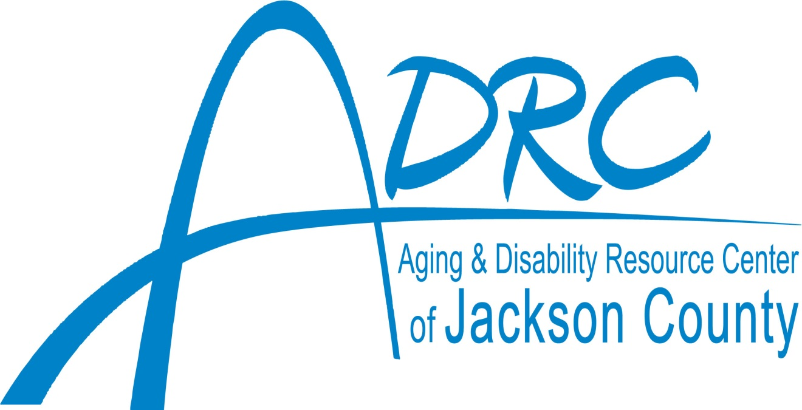
A Division of Jackson County Department of
Health and Human Services
&
The Aging and Disability Services Division

Youth in Transition Resource Guide

Connecting you with Supports and Services

421 County Road R | Black River Falls, WI 54615
715-284-3978 | 1-844-493-4245
Fax: 715-284-7713
Website: adrcjacksoncounty.org
Email: ADRCJC@co.jackson.wi.us

Transitioning into Adult Disability Services
This publication, developed by the ADRC of Jackson County, is intended to help the student with disabilities and their family make the transition into adulthood as smoothly and effectively as possible. In this guide, you’ll find
- A brief overview of the changes, the process, the timeline and the resources involved for a young person with special needs and/or disabilities to transition from adolescence into adulthood.
- How and when the ADRC can help you understand your new rights and responsibilities, determine your immediate and future care needs and evaluate your options for meeting those needs.
- Links to resources and organizations that will help you make more informed choices about living as an adult in Jackson County.

Beginning 6 months before your 18th birthday, the ADRC can help you, your family and your transition team, this process seamless, productive and less stressful. We can help you identify the questions to ask and find answers specifically tailored to your situation.

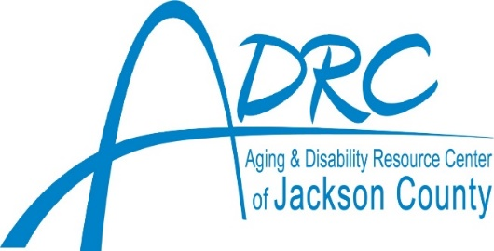
Aging & Disability Resource Center of Jackson County
421 County Road R
Black River Falls WI, 54615
715-284-3978
Find us online: www.adrcjacksoncounty.org
Email us: ADRCJC@JacksonCountyWI.gov
Hours of Operation: Monday – Friday 8:00am - 4:30pm

Transitioning to Adulthood starts early!
Age 14 – 17 years and 6 months:
- Talk with parents, teachers, counselors, friends or anyone else you trust to think about what to do after high school.
- Decide what goals are important to you and take part of your Individualized Education Plan (IEP).
- Educate yourself- learn about your disability, know how it affects you
- Know your benefits- Do I have Social Security Income? Other income?
- Get to know your doctor and your medications
- Get work experience – at 16 you can start working without a worker’s permit
- Prepare for graduation or consider staying in high school after senior year
- Apply for college
Age 17 years and 6 months:
If you are not already involved, become familiar with the ADRC! They can help with:
- Provide links to helpful information, resources and organizations
- Legal issues such as Guardianship, Power of Attorney, Advance Directive options and Supported Decision Making.
- Consider your interests and preferences about post high school work or education possibilities
Age 18: Congratulations! You’re a ‘legal adult’ – now what?
- Sign medical permission forms
- Contact Social Secuirty about your benefits
- Register to vote
- Register for the draft – required for all males
- For a full list of your rights and responsibilities as an adult go to: Wisbar.org

To see a longer list, go to: http://www.beforeage18.org/action-steps/

Here to help!
Disability Benefit Specialists (DBS)
Within the ADRC, disability benefit specialists provide free and confidential assistance to people with disabilities between ages 18-59. They provide current, accurate information about public and private benefit programs; counsel individuals about eligibility requirements for programs and benefits; help people apply for or appeal a denial of benefits. Some programs a DBS can help with are:
- Medicaid
- Social Security Disability Income (SSDI)
- Supplemental Security Income (SSI)
Contact the Jackson County DBS, Megan Olson at 715-284-4301 x373.
Benefits
Once you turn 18, your parents no longer have the legal responsibility to support you financially. It is important to think about how you will support yourself and manage your own money. If you are unable to earn enough money to support yourself because of your disability. Contact your local Social Security office by phone 1-866-815-2924 or in person at 4120 Oakwood Hills Pkwy, Eau Claire WI, 54701 as you might be eligible for one or more of the benefits below through Social Security Administration (SSA):
- Supplemental Security Income (SSI): benefits are not based on you or a family members prior work history; you must have limited income and resources. If approved for SSI you automatically qualify for Medicaid.
  - If on SSI when you turn 18, you will be subject to a disability review of your record to see if you are eligible as an adult.
  - If not already on benefits, you can apply for SSI the month of your 18th birthday
- Social Security: If you have been determined disabled by Social Security and have a parent who retires, receives Social Secuirty Disability Income, or is deceased, you may be eligible for Disabled Adult Child (DAC) benefits, based on your parents’ work history. To apply for DAC, you use the same application as SSI.

Financial Decision Making
Managing finances and budgeting are difficult for many young adults, so it is important for you to ask for help if you need it. You can get financial decision-making support in a number of ways:
- Voluntary Banking Restrictions: gives a parent or another trusted adult access to your bank accounts, records and bills so that they can provide the assistance that you need. It is very important that the person you give this access to is a trusted adult and someone who is looking out for your best interest.
- Power of Attorney (POA) for Finances: allows you to choose a trusted adult who will manage or help you manage your money and assets. You determine what money or assets you want that person (called an agent) to have authority over.
- Representative Payee: If you receive SSI or SSDI benefits and need help managing your money, Social Secuirty Administration can appoint a relative, friend or another interested party or a professional agency to serve as your payee. Your benefits are then paid to your payee on your behalf.
- Guardian of the Estate: (The most restrictive option for financial decision making). This type of guardianship is set up after a person has been determined “incompetent” by a judge and therefore does not have the capacity to make financial decisions on his/her behalf. A court will only appoint a Guardian of the Estate if it finds that there is no less restrictive intervention available that the individual needing help will accept.
For more information contact our Adult Protective Services (APS) staff:
APS-JC@Jacksoncountywi.gov or at 715-284-4301

Health Care Decision Making
Managing your health can be complex, it is important to ask for help if you need it. You can get health care decision-making support in a number of ways:
- Release of Medical Records and Information: Once you become an adult, your health care providers can no longer give information to anyone without your permission, including your parents. If you would like to grant your doctor permission to release all or a portion of your medical records to your parents or another person you can fill out a “Medical Release Form” and sign it. This is one way to give a trusted adult access to your medical information so that they can help you understand and make decisions regarding your health care.
- Supported Decision Making: is a way for people with disabilities to get help from trusted family members, friends and professions to help them understand the situations and choices they face so they can make their own decisions.
- Power of Attorney (POA) for Health Care: an important document that should be filled out by every capable adult, regardless of disability. The form allows you to name a trusted adult as your health care decision maker (agent) in the event you become incapacitated and cannot make decisions for yourself. It also provides the opportunity for you to express preferences about your care.
- Guardian of Person: (The most restrictive option for health care decision making). This is set up when a person is unable to make decisions that meet their needs for physical health and safety. If this is the situation, an alternative decision maker (called a guardian) is legally appointed to make decisions for that person (called the ward).
For more information contact our Adult Protective Services (APS) staff:
APS-JC@Jacksoncountywi.gov or at 715-284-4301

Health Insurance Options
Once you turn 18, your eligibility for health insurance coverage may change. Health insurance helps pay for medical expenses including office visits with your doctors, hospital stays and medications. Without health insurance, most people cannot afford the cost of health care. See possible options below:
- Private Health Insurance through employment: If joining the workforce after high school, you may qualify for health insurance coverage through your place of employment. Not all employers offer health benefits, so it is important to ask about offered benefits before accepting a job. Most employer offered plans require you to pay monthly premiums and a yearly deductible.
- Private insurance through Health Insurance Marketplace: learn more about affordable health insurance at www.healthcare.gov or 1-800-318-2596.
- Continuation of family plan as dependent adult: You may remain as a depend on your parents’ insurance until the age of 26.
- Medicaid/ Badgercare: Medicaid pays for medical services such as hospital stays, doctor appointments and prescription drugs. There are several different Medicaid programs available in Wisconsin and each one has slightly different criteria. For more information about Medicaid or BadgerCare, contact Western Region for Economic Assistance (WREA) at 1-888-627-0430 or online at https://access.wisconsin.gov
Long-Term Care Programs
Publicly funded Long Term Care (LTC) programs provide a wide range of long-term care support services to eligible members. Potential members are adults over age 18 with physical or developmental disabilities and elderly persons with long-term conditions requiring care. You must be functionally and financially eligible in order to enroll.
- Functional eligibility screen: gathers information about individual needs and how much help you need to perform activities of everyday life- for example, walking, bathing, eating and managing medication.
- Financial screen: based on income and assets.
The ADRC staff will assess the potential member’s eligibility for these programs and what program will meet your needs. Contact your ADRC for more information.
Post-Secondary Education
If you have decided to transition to postsecondary education after graduation, it is important to know there are many differences between high school and college. Postsecondary education is governed by different laws and formal special education services are not available. Most colleges have a Special Needs Office where students with disabilities can go for support and assistance with accommodations.
Record Keeping
Before you leave high school, obtain a copy of all transcripts, evaluations, tests and transition Individualized Education Programs. Often times, these records will be needed when coordinating adult services. Schools do not keep student records very long, so it is important that you request your own copies before, or right after, leaving high school. In addition to keeping school records, it is just as important to keep medical records including any documentation from physical therapists, occupational therapists, psychologists, pediatricians and specialists. Keeping these types of documents organized and easily accessible will save you time and make your transition into the adult world a much smoother one.
Still have questions? Use the space below to make notes to ask your Disability Benefit Specialist.
NOTES:
________________________________________________________________________________________________________________________________________________________________________________________________________________________________________________________________________________________________________________________________________________________________________________________________________________________________________________________________________________________________________________________________________________________________________________________________________________________________________________________________________________________________________________________________________________________________________________________________________________________________________________________________________________________________________________________________________________________________________________________________________________________________________________________________________________________________
Jackson County Youth in Transition Services
This document is not all-inclusive and is NOT meant to be an endorsement or recommendation of these agencies
Jackson County ADRC (Aging and Disability Resource Center)  The ADRC assists in the transition of young people moving from children’s services to adult services. | - ADRC of Jackson County  - 421 County Road R, Black River Falls  - 715-284-3978  - ADRC Youth in Transition Website  - ADRC Referral Form
Advocacy | - ADRC of Jackson County  - Disability Rights Wisconsin  - 800-928-8778  - Family Voices of Wisconsin  - Independent Living Resources (ILR)  - 608-787-1111  - National Alliance on Mental Illness (NAMI)  - 800-950-6264
Adult Day Services/ Respite Care  Programs designed for those who require supervised care during the day or those who are isolated and lonely | - A New Day  - 608-989-2323  - A Time for You  - 715-284-7058  - International Quality Home Care  - 715-538-4609  - ResCare  - 608-779-0900
Adult Services for Long Term Care  See your ADRC Long Term Care options counselors for more information and to enroll | - ADRC of Jackson County  - 715-284-4301  - Family Care  - Inclusa  - My Choice Wisconsin  - IRIS  - Connections (LSS)  - TMG  - Advocates For You
Behavioral Health  Promote wellness through advocacy, education and comprehensive mental health and substance use related services for children, youth and adults | - Jackson County Behavioral Health  - 715-284-4301 x312  - JC Referral Form  - CCS Comprehensive Community Services  - CSP Community Support Program  - Northwest Connections (Crisis)  - 888-552-6642
Benefit Assistance  Provide assistance related to applying for or appealing Social Security Disability determinations; applying for other public benefits (Food Share/ Medicaid) | - ADRC of Jackson County  - 715-284-4301  - Disability Benefit Specialist x373
Continued Education  For those seeking to continue their education after high school | - Chippewa Valley Technical College  - 715-833-6200  - Ho- Chunk Nation Education  - 715-284-4915  - University of Wisconsin System  - Western Technical College  - 800-322-9982
Employment Assistance | - APTIV  - 715-284-2546  - Department of Vocational Rehab (DVR)/DWD  - 800-253-2139  - Career Development Center  - 715-834-2771  - WI Job Center  - 608-374-7740  - Workforce Connections, Inc.  - 715-284-7117
Financial Planning  Assists with ABLE Accounts, Guardianship and Rep Payee financial strategies, Special Needs Trusts and Estate Planning | - Quantum Group  - 608-790-1354  - Joel Dettwiler, ChSNC
Food/ Meal Alternatives | - Friends Sharing Food  - 715-670-8489  - Jackson County Food Pantry  - 715-896-3601  - Neighborhood Food Pantry  - 715-284-3346  - Western Region for Economic Assistance (WREA) - Financial food assistance  - 855-293-1822
Hospital and Clinic | - 9-1-1 (Emergency Phone Number)  - Black River Memorial Hospital  - 711 W Adams St Black River Falls  715-284-5361  - Gundersen Health System  - 800-362-9567  - Krohn Clinic  - 610 W Adams St Black River Falls  715-284-4311  - Marshfield Clinic  - 800-782-8581  - Mayo Clinic Health System  - 800-362-5454
Housing | Assisted Living Facilities  - Residential Care Apartment Complex (RCAC); Adult Family Living (AFL), Community Based Residential Facilities (CBRF)  Independent Housing  - Black River Housing, LLC 715-284-4235  - Country View Apartments 715-928-0138  - Farm Urban Holdings 715-282-0936  - Frontier Property Management 608-634-6448  - Jackson Co Housing 715-284-2041  - Richard Bruesefhoff Villa 800-685-9353  - Rye Bluff Town Houses 715-284-5148  - Town and Country Apts 715-964-2406  - Union Place 608-822-7368
School Districts  Each school district will likely have multiple people to support the transition planning, contact your local school or teacher for more information | - Alma Center- Humbird- Merrillan  - Black River Falls  - Blair- Taylor  - Melrose- Mindoro  - WI FACETS Transition IEP Checklist  - Tiffany Lisk 608-786-4828
Social Security  Check eligibility for benefits, apply for benefits, check application or appeal status, appeal benefits, sign up for Medicare or plan for retirement | - Social Security Administration  - 4120 Oakwood Hills Pkwy, Eau Claire  - 866-815-2924
Supported Decision Making and Guardianship | - Immediate Life-threatening emergency  - 715-284-5357  - Jackson Co Adult Protective Services  - 715-284-3978  - APS-JC@Jacksoncountywi.gov  - APS Referral Form  - Supported Decision Making  - Supported Decision Making Agreement Form  - Guardianship  - WI Guardianship Support Center  - 855-409-9410  - F-00036 Power of Attorney for Finances and Property  - P-00085 Power of Attorney for Health Care
Recreation/ Social Activities | - APTIV  - Black River Falls Public Library  - Independent Living Resources (ILR)  - Lunda Community Center  - North American Squirrel Association (NASA)
Transition Improvement Grant (TIG)  Can provide resources for transition planning for schools and families on guidance with laws and best practices | - Beforeage18.org  - Transition Action Guide  - District Transition Planning Form with Contacts  - Parent / Youth Guide to Post-Secondary Transition Planning
Transportation  Medical and non-medical transportation options | - ADRC of Jackson County  - 715-284-3978  - Black River Falls Transit  - 715-284-4511  - Pine Creek Transport Services  - 715-662-2028  - Veyo  - 866-907-1493

