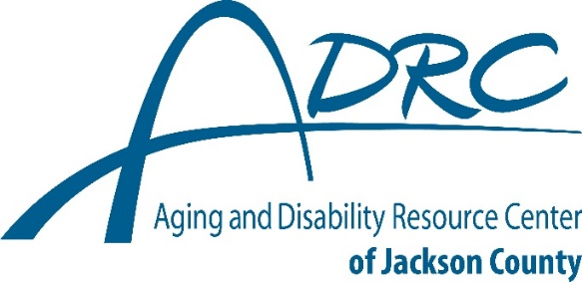

CLEANING SERVICES
DISCLAIMER
Inclusion in this service list does not imply endorsement or recommendation of an organization, service, support, or program. Omission from the service list does not indicate disapproval of an organization, service, support, or program. The quality of an organization, service, support, or program is not guaranteed by DHS. DHS, ADRCs, aging units, and Tribal partner agencies are not responsible for programs, supports, or services provided by any organization or provider included in the directory.

Darion Reinart Cleaning Services
715-497-9017

Kitelingers Kleaners
715-828-9689

Maid You Look
608-284-0898

Mays Cleaning Services
715-896-1736

Meticulous Cleaning
715-299-0219

Northwoods Neat Cleaning Services
715-937-6987

Sara Parker Cleaning Services
Home and Car Detailing
715-299-9993

Serene Clean
715-204-4270

Service Master of Clark & Jackson County
715-284-0770

Spotless Cleaning
608-633-5989

Super Clean
262-721-2401

