

HOME CARE SERVICE LIST (2026)
Agencies Serving Jackson County
BrightStar Care
https://www.brightstarcare.com/locations/lacrosse/
Onalaska: 608-394-3251
Offers: Companion Care, Respite, Light housekeeping, Home Safety Evaluations, Personal Cares, Hospice Assistance, Skilled Nursing Care (Ie: Medication Administration, Wound Care, Physical/Occupational/Speech Therapy, etc.)
Accepts: Private Pay, Private Health Insurance, VA Benefits, Medicare, Medicaid, Private Long-term care insurance.
Clear Water Home Care LLC
https://cwhc.co/services
Eau Claire: 715-514-1520
Offers: Personal Cares & Supportive Care, Light housekeeping, Transportation to appointments, meal preparation.
Accepts: Medicaid, Private Pay
Call to discuss pay sources/rates
Cornerstone Caregiving
https://cornerstonecaregiving.com/eauclaire/
Eau Claire Office: 534-444-9021
Offers: Personal & Supportive Care (including errands, housekeeping, meal preparation, and transportation.)
Accepts: VA Benefits, Long-term care Insurance, & Private Pay.
Private Pay Rates: $48 per hour for 1 hour | $40 per hour for 2-3 hours | $32 per hour for 4+ Hours

Hampel Home Health Care LLC
FACEBOOK: https://www.facebook.com/share/1Zw3DRHNXm/
Sparta: 608-633-8805
Offers: Skilled Nursing Care (Wound management, post-surgical support, chronic condition monitoring/education, and medication administration.)
Call to discuss pay sources/rates

Home Instead
https://www.homeinstead.com/location/886
La Crosse: 608-406-2895
Offers Personal care, Alzheimer’s & Dementia Care, Hospice Support, Chronic illness care, home help (light housekeeping, cooking, list prep, etc.), Transportation, Companionship, etc.
Accepts: long-term care insurance, private pay. (subject to change)

*Continues to next page*

Integrity Home Healthcare
FACEBOOK: https://www.facebook.com/share/1C1mM6VMF2/
Eau Claire: 715-944-9065
Offers Personal Care, Supportive Home Care & Alzheimer’s & dementia care in Jackson County. Black River Falls is the farthest they travel. Call for rate requests.

Interim
https://www.interimhealthcare.com/location/eau-claire-wi
Eau Claire: 715-834-1313
Offers: Home healthcare, physical/occupational/speech therapy. Skilled nursing services to manage wound care dressings, medications, etc. Palliative services to help manage chronic diseases. Hospice team to support end of life transitions and care.
Accepts: Medicare, Medica, UHC-Dual Complete, Humana, Senior Health Plan, VA, and others. Private pay also accepted for PT/OT and Skilled nursing services.

International Quality Home Health Care/Alpha Services
www.internationalquality.com
Tomah 833-682-4742
Neillsville 866-591-5073
Note: Both locations service Jackson County area upon care worker availability.
Offers Nursing Care & Supportive Care Services
Accepts: Medicare, Medicaid, MyChoice, Inclusa, & Private Pay (Call for Rates)

Lakeland Home Health
https://www.lakehhc.com/
For referrals: 715-239-2075
Offers Skilled Nursing, Occupational Therapy, Physical Therapy, Speech Therapy, Medical Social Services, and home health services.
Accepts: Medicare, Medicaid, Various Private Insurance, Private Pay Options for Outpatient therapies

Lori Knapp Companies
https://loriknappcares.com/
La Crosse Office: 608-781-4594
Offers: Supportive Care, Housekeeping, Shopping, Appointment transportation, Respite care, Housing counseling, & Support Broker services.
Accepts: My Choice, Inclusa, VA, Private Pay ($27 per hour) and some Private Insurance (call to inquire)

Moore Genuine Care, LLC
FACEBOOK: https://www.facebook.com/Genuinehomecare
Augusta: 715-286-2734
Offers: Skilled Nursing Visits, Hospice Services
Call to discuss pay sources/rates

*Continues to next page*

Safe at Home Senior Care
http://www.sahsc.org/non-medical-home-care-services
Eau Claire: 715-598-7233
Offers: Companionship, Light Housekeeping, Meal Preparation/Grocery Shopping, Errands, Chores, Medication Reminders, Personal/Supportive Cares, Overnight Cares, Hospital Discharge, Dementia Care & Support.

Village Caregiving
www.villagecaregiving.com
Eau Claire: 715-492-0191
Offers: Basic Home Care Services, Assist with ADL’s, Companionship Care, various Non-Medical Services such as meal preparation and transportation.
Accepts: VA Insurance, My Choice (Non-Contracted), Inclusa (Non-Contracted), IRIS (ilife & GT Independence), LTC Insurance, Health Align AKA Helper Bees, and Private Pay at $30 per hour

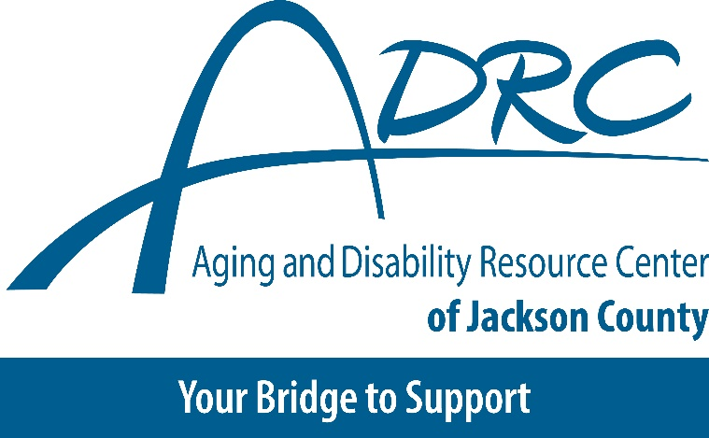

*Information updated as received by the Aging & Disability Resource Center of Jackson County.*

If you notice any information that requires updating or removal, please contact the
ADRC of Jackson County Directly at 715-284-4301 or email: adrcjc@jacksoncountywi.gov

Inclusion in the resource directory does not imply endorsement or recommendation of an
organization, service, support, or program. Omission from this directory does not indicate
disapproval of an organization, service, support, or program. The quality of an organization, service, support, or program is not guaranteed by DHS. DHS, ADRCs, aging units, and Tribal partner agencies are not responsible for programs, supports, or services provided by any organization or provider included in the directory.

